**Computer**

**Network**

**Class Six**

**Lab 5**

|  |
| --- |
| Lab Objectives:  * Hub * Switch * Router * Modem * LAN |

# Network Devices

## Networking hardware, also known as network equipment or computer networking devices, are physical devices which are required for communication and interaction between devices on a computer network.

## IMG_256

## Before knowing about hub, switch and router you have to know about LAN and WAN

# LAN

## A LAN (local area network) is a computer network that interconnects computers within a limited area such as a residence, school, laboratory, university campus or office building.

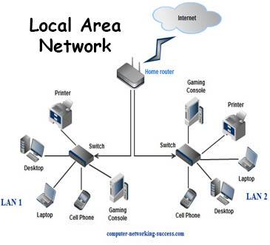

# WAN

A wide area network (WAN) is a telecommunications network, usually used for connecting computers, that spans a wide geographical area.

# IMG_256

# Hub vs Switch vs Router: What Are Hub, Switch and Router?

# Hub

## Hub is commonly used to connect segments of a LAN (Local Area Network). A hub contains multiple ports. When a packet arrives at one port, it is copied to the other ports so that all segments of the LAN can see all packets.

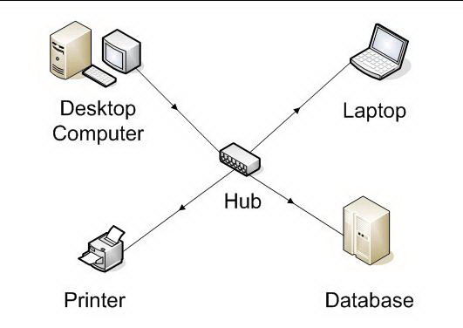

# Switch

## A network switch is a computer networking device that connects devices on a computer network by using packet switching to receive, process, and forward data to the destination device.

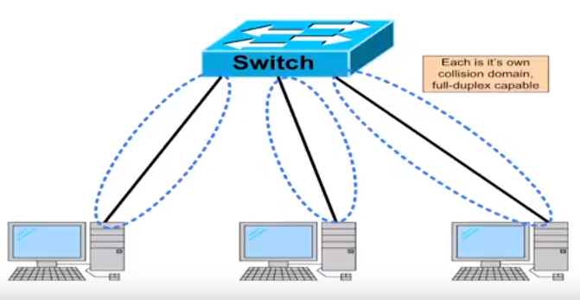

# Router

## A router is connected to at least two networks, commonly two LANs or WANs (Wide Area Networks) or a LAN. A router forwards data packets between computer networks. Routers perform the traffic directing functions on the Internet. Data sent through the internet, such as a web page or email, is in the form of data packets.

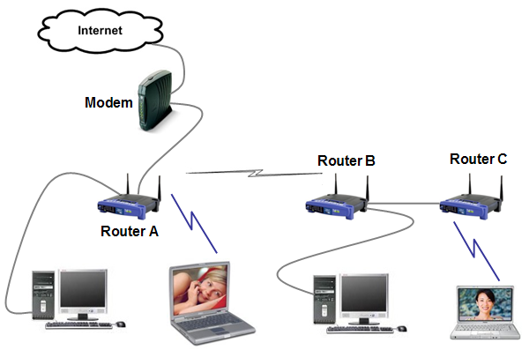

# Modem

A modem is a hardware device that converts data between transmission media so that it can be transmitted from computer to computer.

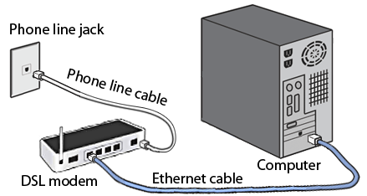

# Hubs vs Switch vs Router

## Hubs, switches, and routers are all devices that let you connect one or more computers to other computers. Each has two or more connectors called ports, into which you plug the cables to make the connection.

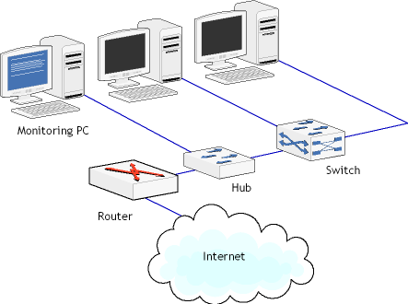

## Hubs are “dumb” devices that pass on anything received on one connection to all other connections.

## Switches are semi-intelligent devices that learn which devices are on which connection.

## Routers are essentially small computers that perform a variety of intelligent tasks.